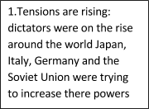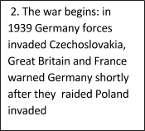

10. The world supports the war by planting many crops for the economy and raised cotton and live stock

8. Allied forces came to Poland, Austria, and Germany to find the remains of the Holocaust

6. British and American troops raided North Africa and gained control

9. After the declaration of war Georgia put out over 320,000 people out for war

7. Japan began to capture many pacific native countries

4. Millions of Americans joined the military Via the bombing of pearl harbor

5. The Tuskegee Airmen were formed

3. Japan bombs the United States Pearl Harbor